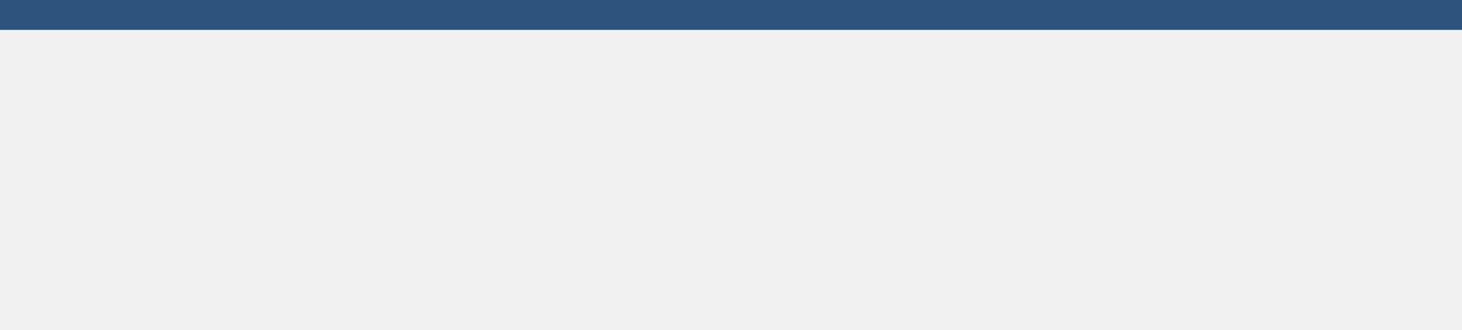

**Email:** [itsdivyanshu799@gmail.com](mailto:itsdivyanshu799@gmail.com)

**Phone: +91 8932841719**

**Address: 75, Pitamber Ganj, Railway Ganj, Hardoi, UP,241001**

**LinkedIn:** linkedin.com/in/divyanshu-gupta-84ab8115

**DIVYANSHU GUPTA**



**BCA STUDENT** 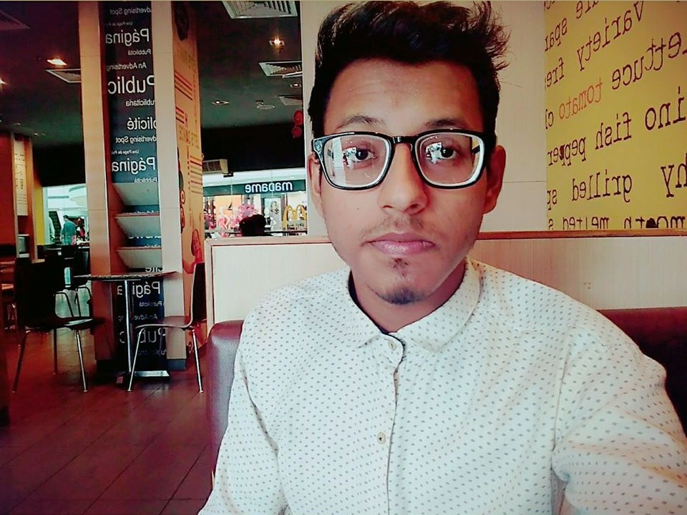

**O B J E CT I V E:**

To strive for excellence to work in such an environment that will enhance my knowledge and career, where I can perform my management as well as technical skills according to my strong caliber and efficiency.

**SKILLS:**

Strong Work Ethic Ethic

Problem Solving

Handling Pressure

Collaboration.



Time Management

Content Writing

* Awarded a certificate of **Excellence** for slogan competition in 2010 on the occasion of International Earth Day organized by Science Aur Kainat society of India, New Delhi
* Awarded a certificate of **Best** Position in 2014 by Bhartiya Sanskriti Gyan Pariksha.
* Awarded a certificate of **Participation** by APTRON, New Delhi for attending one day workshop in 2018.
* Awarded a certificate of **Best** Position in 2010 by Bhartiya Sanskriti Gyan Pariksha.
* Awarded a certificate of **Excellence** in a Quiz Programme organized by APTRON, New Delhi.
* Awarded a certificate of **Participation** in Bharti AXA Life Insurance Quiz Competition.
* Awarded a certificate of **General** Position in 2015 by Bhartiya Sanskriti Gyan Pariksha.
* Awarded a certificate of **General** Position in 2013 by Bhartiya Sanskriti Gyan Pariksha.
* Awarded a certificate of **Participation** in Personality Development Workshop.
* Awarded a certificate of **Performance** in Volleyball competition in 2015.

Leadership

Gaming.

Communication

Web Designing

**BOARD / UNIVERSITY**

Invertis University

**EXAMINATION NAME**

BCA 2nd Year

**PERCENTAGE / CGPA**

71.02%

**INSTITUTE NAME / YEAR**

Invertis University,

Bareilly (2018-2019)

**EDUCATION:**

**ACADEMIC CERTIFICATE PROGRAMME / WORKSHOP TRAINING:**

Invertis University,

Bareilly (2017-2018)

Shri Guru Ram Rai Public School, Hardoi

(2016-2017)

Shri Guru Ram Rai Public School, Hardoi

(2014-2015)

BCA 1st Year

Intermediate (XII)

High School (X)

66%

73.9%

76% (8.0 CGPA)

Invertis University

CBSE Board

CBSE Board

**NON-ACADEMIC CERTIFICATE PROGRAMME:**

* Awarded a certificate of **First** position in LAN Gaming (CS1.6) held on 28-30Sep,2018 by Jaipur National University.
* Awarded a certificate of **First** position in LAN Gaming (CS1.6) held on 26-28Sep,2019 by Jaipur

National University.

* Awarded a certificate of **Second** position in LAN Gaming (CSGO) in 2018 by Invertis University, Bareilly.
* Awarded a certificate of **First** position in Nukkad Natak in 2018 by Invertis University, Bareilly.
* Served as **The President** of **THE RESPONSIBLE INVERTIAN CLUB** 2018-2019.
* Served as **Co-convener** of The **Annual Fest** – 2019 at Invertis University.
* Served as **Host** in Fresher’s Party.
* Served as **Field Organizer** and **Construction’s Supervisor** at Auto Expo 2020.
* Awarded a certificate of **First** position in LAN Gaming (CSGO) in 2020 by Invertis University, Bareilly.

**INTERESTS:**

* Reading Novels.
* Playing PC Games.
* Listening to Music.
* Watching TV shows and Movies of Hollywood.
* Managing as well as participating in various events.
* Learning Tricks and Tips of Windows and Android.
* Speaking.

**Declaration:**

I hereby declare that the information provided above is true and the best of my knowledge and belief.

**DATE – 31/12/2019**